Top of Form

Bottom of Form

[**Aptitude and Reasoning Assessment**](https://aptitudereasoningassessment.blogspot.com/)

**Aptitude Test Web App using Streamlit and LLMs**

[July 25, 2025](https://aptitudereasoningassessment.blogspot.com/2025/07/aptitude-test-web-app-using-streamlit.html)



**🧠 Introduction**

In today's competitive environment, assessing aptitude and reasoning skills has become essential for job placements and government exams. To address this, **our team developed** an **Aptitude Test Web App** using **Python, Streamlit**, and **LLM (Groq’s LLaMA-3)**. The application dynamically generates multiple-choice questions across three core sections: **Quantitative, Logical**, and **Verbal**, simulating a real exam experience.

**💻 Tech Stack**

* **Frontend & App**: Streamlit
* **Backend AI Model**: LLaMA-3 via Groq API
* **Data Visualization**: Plotly
* **Language**: Python

**🎯 Objective**

To build a dynamic aptitude test platform that:

* Generates section-wise questions of varying difficulty using an LLM.
* Tracks user performance in real-time.
* Displays section-wise scores and feedback after the test.

**🧪 Test Structure**

* **Total Questions**: 45
* **Sections**: Quantitative, Logical, Verbal
* **Each Section**: 15 questions (5 Easy, 5 Medium, 5 Hard)
* **Time**: 1 min per question
* **Scoring**: +1 per correct answer, no negative marking

**🛠️ Features**

1. **User Input Page** – Name, email, and phone number.
2. **LLM-based Question Generator** – Uses Groq's LLaMA-3 to generate MCQs from real exam topics like SSC, CAT, GATE, etc.
3. **Timer per Question** – 60-second timer per question.
4. **Dynamic Section Loading** – Each section starts with instructions and then loads questions.
5. **Live Answer Tracking** – Saves responses section-wise.
6. **Final Result Page** – Shows:
   * Overall score and rating (Excellent, Good, Average, Needs Improvement)
   * Section-wise performance
   * Plotly Pie & Bar Charts
   * Personalized feedback

**📊 Data Visualization**

* **Pie Chart**: Shows overall score
* **Bar Graph**: Section-wise accuracy
* **Data Table**: Displays correct answers per section and overall accuracy

**🤖 AI-Generated Questions**

All questions are generated live using this LLaMA-3 prompt:

*“Generate 15 multiple-choice questions of varying difficulty for [section] covering topics like Profit & Loss, Coding-Decoding, Grammar, etc.”*

Each question includes:

* Question text
* 4 answer options
* Correct answer for scoring

**💬 Personalized Feedback**

After the test, users receive motivational and section-wise feedback:

* **Above 80%**: Excellent – Practice advanced sets
* **60–79%**: Good – Strengthen concepts
* **40–59%**: Average – Focus on basics
* **Below 40%**: Needs Improvement – Start with foundations

**📷 Screenshots of the App**

🖼️**User Details Page**

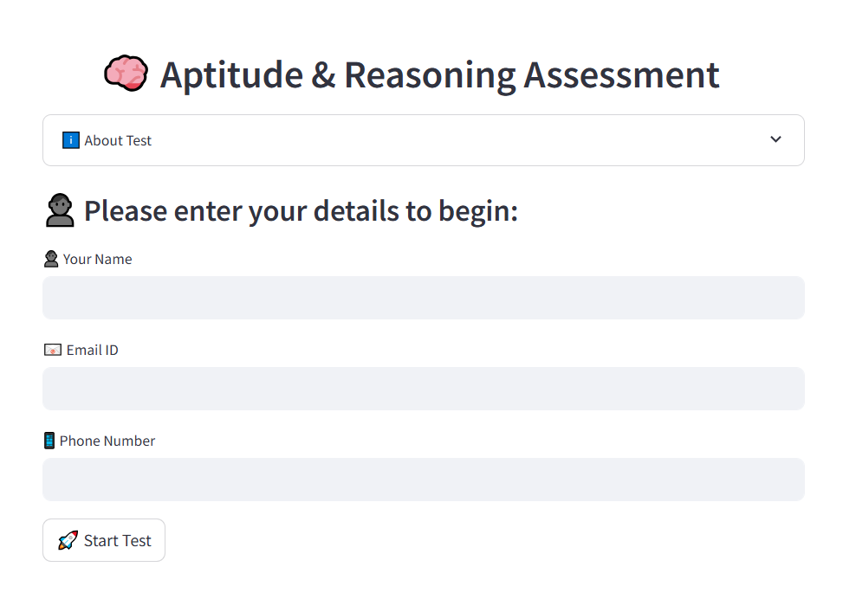

🖼️**Section Introduction Page**

Before each test section begins, the app displays a brief overview of what topics are covered and how the section is structured. For example:

* **Quantitative Aptitude** includes Profit & Loss, Time & Work, Percentages, etc.
* **Logical Reasoning** covers Number Series, Puzzles, Blood Relations, and more
* **Verbal Ability** focuses on Reading Comprehension, Grammar, Vocabulary, etc.

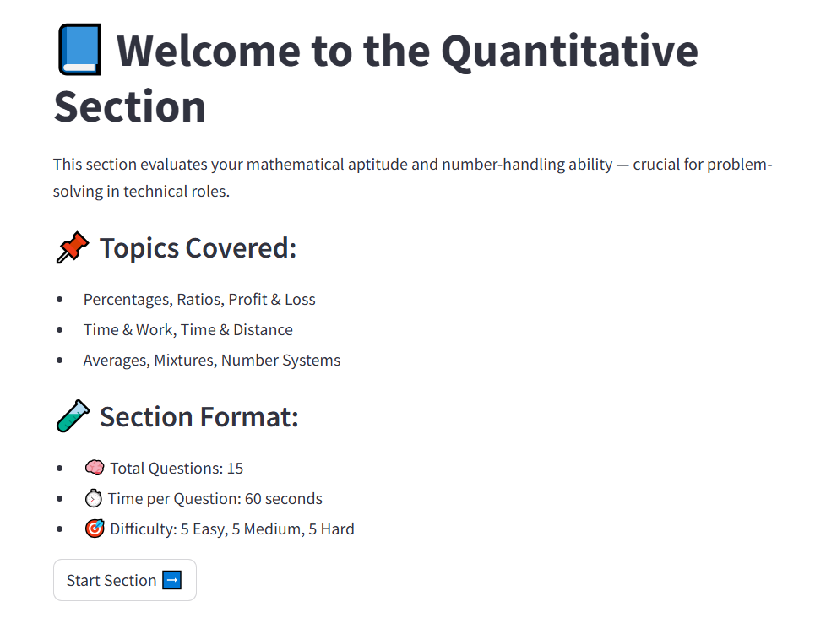

🖼️ **Question Page with Timer**

During the test, each section presents **one question at a time** with a **60-second countdown timer**. The question includes:

* A multiple-choice format with **4 options**
* A **"Next" button** to proceed (automatically moves if time runs out)

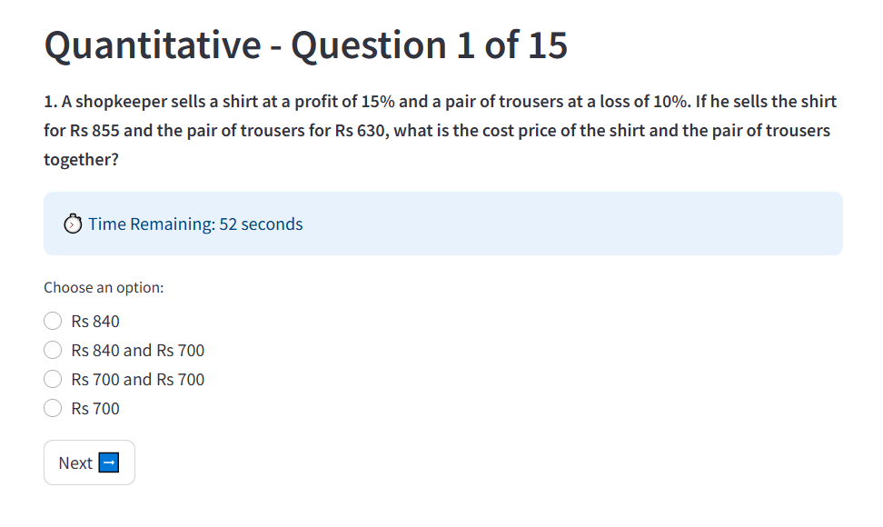

**📊 Final Score Pie Chart**

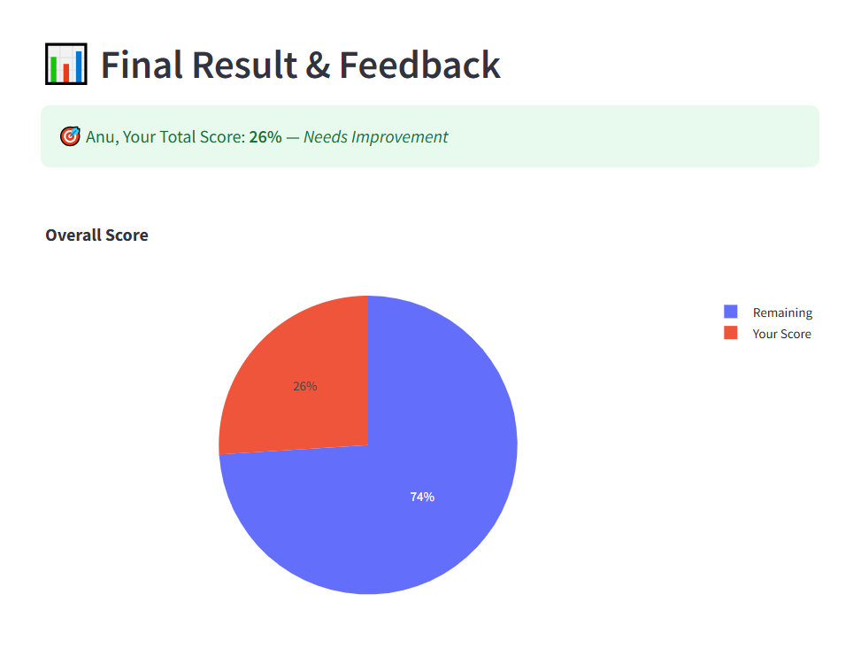

A pie chart shows your total score as a percentage of correct answers.

**📊 Section-wise Accuracy Bar Chart**

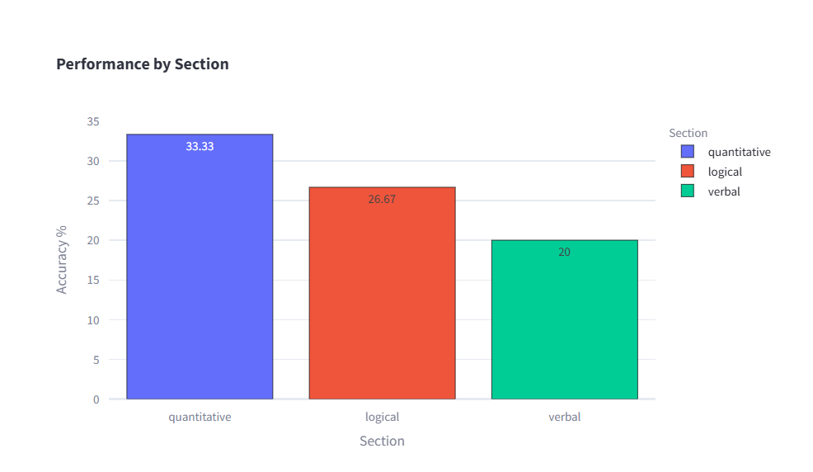

A bar chart displays performance in each section: Quantitative, Logical, and Verbal.

🧾 **Section-wise Performance Table**

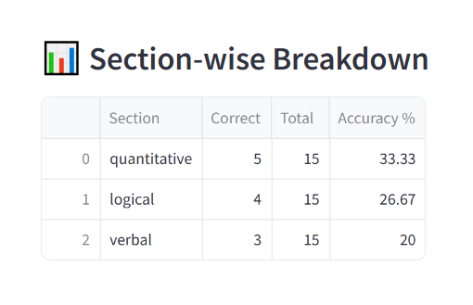

A table summarizing total questions, correct answers, and accuracy percentage per section.

📝 **Personalized Feedback Display**

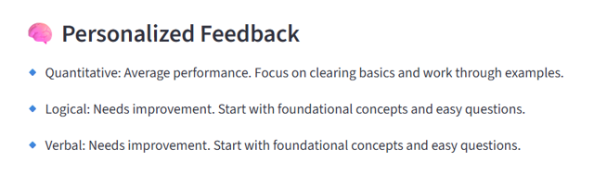

Based on your score, the app generates section-wise tips and encouragement messages.

🔚 **Conclusion**

This team project helped us explore real-time UI development using **Streamlit**, integrate **LLMs (LLaMA-3 via Groq)** for dynamic question generation, and apply **Plotly** for data visualization. It demonstrates how AI and app development can be combined effectively in EdTech to create interactive learning tools.